To: Dr. Oman

From: Jacob Belin, Richard Campos, Jackie Fonseca, Zack Retzlaff

Date: September 25, 2020

Subject: Implementation Memo

**Introduction**

General Atomics created a capstone project where a team of students would have to come together to design a testing fixture that would secure a 12U CubeSat to an air bearing stand while relocating the center of gravity of the entire assembly. The fixture must be adaptable to take in different payloads of where the weight of the CubeSat is located and correct the center of gravity to a specific point directly above the air bearing stand. The team started this project a semester ago, and throughout the first semester designed a model of the fixture. At the beginning of this semester the team has started prototyping and have completed more calculations. Both of which have caused changes to the design. The changes to the design are described in breakdown of each of the Engineering Requirement changes, and the changes in the sub-systems.

# 1.0 Customer Requirements (CRs)

The client provided an initial project description which listed many of the immediate customer requirements. After further discussion and more information from the client, the team determined the following list of customer requirements for the mounting fixture design. The mounting fixture’s primary need is to refocus the center of gravity (CG) to the origin of the mounting fixture.

The mounting fixture is expected to be the interface between the CubeSat and the air bearing test stand. From this general function, the CubeSat should have an efficient method for installing, securing, and removing the CubeSat from the fixture and prevents the whole fixture from falling off the test stand. If the project becomes cumbersome to work with, there is potential to damage the satellites and the mounting fixture. Our design incorporates these requirements by utilizing tabs on the edges of the CubeSat. These tabs are designed by GA to anchor the CubeSat inside their dispenser device. The team is planning to use the shape of the tabs to create a slot for the CubeSat edges to slide into and the tabs prevent the CubeSat from coming away from the platform.

In the discussion with the client, we noticed they mentioned repeatability for their testing. The team interpreted the customers repeatability as a call for durable, lasting design that could reliably produce the same results. In the previous semester, we attempted to create a tentative BOM which would only consume 10% of the total budget. After further consideration of the material selection and choosing high-sensitive equipment, we are confident that our design will produce accurate results and will reproduce results. By increasing our target expenditures, our team was able to purchase quality materials. Our steps moving forward will affect the overall durability of the design but with careful planning, we can produce a rigid mounting fixture. In addition to better performance and strength, our material selection is keeping in mind the weight capacity of the air-bearing test stand. Fortunately, our team leader Richard has experience in robotics and has brought his insight into vendors for hobbyist. The products from these vendors are suited for robotics. In other online stores, we would find a similar device that we would need to modify to fit our purposes. This is a major concern for weight tolerances because everything we would use require more parts to attach other sub-assemblies.

The following customer requirements are derived from discussion with the client about how they intend to use the mounting fixture. One test they perform is inside a Helm Holtz coil to null the magnetic field around the CubeSat to mimic the magnetic field in space. Our design must be built entirely of non-magnetic components as this will interfere with the measuring devices inside the CubeSat. In addition, our design must be transported between different locations within the client facilities and around small chambers like the Helm Holtz coil. We interpreted this as a need to limit the geometric size.

The customer requirements discussed above were maintained throughout this semester and the former. We noticed those are the requirements that influence our design decisions the most and we notice their implementation into the design more explicitly than others. One requirement that changed since the previous semester is the compatibility with other payloads beyond CubeSats. GA is an advanced technology company and have many applications they could test. We attempted to create securing mechanisms that could adjust for different geometries but incorporating this requirement made calculating the CG extremely complex. We are now designing the mounting fixture to accept only CubeSats, regardless of its size. Unfortunately, this does not allow our fixture to be compatible with the CSD device that the client uses for orbit missions. This is the only modification to that requirement. Lastly, our fixture was requested to compensate the CG affects of a cord hanging from the CubeSat during a simulation. This requirement was difficult to satisfy with a pneumatic, non-magnetic system so we asked our client to remove that from our CR list. In the future, GA is expecting to use remote connections to communicate simulation data instead of a hardline.

The CRs were evaluated by the team and assigned a rank which correlates to its importance in design. The max rank of 5 was given to the CRs: non-magnetic, secures CubeSat, compatible with test stand, refocus CG and does not fall off the stand. These CRs are embodied most by our design. The CRs that followed with a rank of 4 was the fixture must not fall of the test stand and installing the CubeSat must be practical. Limiting the volume of the fixture and being reliable were assigned rank 3. We are confident our material selection is sufficient to produce a reliable device that isn’t too bulky, so we reduced the rank of these requirements. The lowest ranked CR was limiting the weight of the mounting fixture. The client gave a generous tolerance for the weight of our mounting fixture so this was not critical in overall design but is more critical for refocusing the CG. Since refocusing the CG is among the highest ranked, we give weight considerations the least priority.

# 2.0 Engineering Requirements (ERs)

Every design project must have measurable engineering requirements (ERs) that the final product must accomplish. Each of the ERs must have a specific target and tolerance value associated with it and must be able to be tested for. Each of the ERs that are associated with this design project are listed below with the associated target and tolerances.

## 2.1 ER#1: Accept CubeSat (Lifts Weight)

### 2.1.1 ER #1: Accept CubeSat Target = 24 kg

This engineering requirement is important to the project because the fixture would not do what it is supposed to do without first meeting this requirement. The fixture must be able to hold the weight of the CubeSat in order to perform tests and align the center of gravity, this engineering requirement must be met before others to have a successful project.

### 2.1.2 ER #1: Accept CubeSat Tolerance = ± 2

This tolerance is important to the project because it was given to us in our project description. General Atomics stated the fixture must support 24 kilograms plus/minus 2 kilograms. This is an important requirement to the team because it gives a baseline of what materials to use. In order to support that weight, the team will not be able to use flimsy materials that will cause deformation.

## 2.2 ER#2: Movability in all Axis

## 2.2.1 ER #2: Movability in all Axis - Target = 50 mm

This engineering requirement was given by the client. The customer expects our design to be able to displace a center of gravity by 50 mm in all directions from an original position. If we were to move our counterweights to their maximum positions, this should create a 50 mm displacement for that corresponding counterweight.

### 2.2.1 ER #2: Movability in all Axis - Tolerance = ± 2 mm

A tolerance of 2 mm was given to this engineering requirement as a sense of accuracy our device is expected to have. The client explained that if our design can displace the CG 50 mm accurately in all directions, they fully expect our design to align the CG within 2mm of the prescribed location.

## 2.3 ER3: Limit Tilt Degree

## 2.3.1 ER #3: Limit Tilt Degree - Target = 35 degrees

One of the customer requirements that was given to the team by GA was that the fixture could not exceed a tilt angle of 35 degrees from the z-axis. This requirement was created so that when the device is used during testing, it does not fall off the air bearing table.

### 2.3.1 ER #3: Limit Tilt Degree - Tolerance = ± 1.75 degrees

A tolerance for the tilt angle was given to the team by GA in the project description. This was given to the team so that we do not overexert the CG calculations with over precise readings from the sensors.

## 2.4 ER#4: Allow 360 Degree Rotation

## 2.4.1 ER #4: Allow 360 Degree Rotation - Target = 360 degrees

Because a CubeSat is being used in space, where it is free to rotate freely on all axes. Because the testing conditions do not allow for exactly that to happen, GA wanted to make sure that the fixture could get as close to that as possible, which was determined to be allowing the fixture to rotate 360 degrees about the z-axis.

### 2.4.1 ER #4: Allow 360 Degree Rotation - Tolerance = 0

[Provide a short discussion of how the tolerances for this engineering requirement were created or why they are important to the project.]

Because the nature of this engineering requirement is that our device must be able to make complete rotations without hindrance, there is not any actual tolerance associated with it. That is why it has been determined that the tolerance would be zero.

## 2.5 ER#5: Limit Total Weight

## 2.5.1 ER #5: Limit Total Weight - Target = 50 kg

The air bearing stand that the team's fixture will be sitting on top of has a weight limit capacity. Due to this weight limit capacity and the weight of the CubeSat itself, the team declared that the fixture should weigh less than 50 kg.

### 2.5.1 ER #5: Limit Total Weight - Tolerance = + 2 kg

Due to the weight capacity of the air bearing stand the team does not want to exceed the maximum weight of 52 kg. With this design tolerance and the CubeSats own weight tolerance, when both added are still reasonably under the total weight capacity of the air bearing stand. However, this is just the maximum tolerance for the fixture weight, the team is designing the fixture to be well under this ER.

## 2.6 ER#6: Limit Size

## 2.6.1 ER #6: Limit Size - Target = 9 $m^{3}$

The client will be utilizing the team’s design inside of a Helmholtz coil, for testing purposes on the CubeSat. Due to this fact, the overall size of the design must be able to fit within the Helmholtz coil. Therefore, the ER of limit size is a target of 9 $m^{3}$ so that the fixture can enter and sit within the Helmholtz coil.

### 2.6.1 ER #6: Limit Size - Tolerance = ± .045 $m^{3}$

The tolerance for the size is 0.045 $m^{3}$ because having the design within this volume will still allow it to fit within the area needed.

## 2.7 ER#7: Material Strength

## 2.7.1 ER #7: Material Strength - Target = 200 MPa

This engineering requirement was created to meet the engineering requirement stated in 2.1. To ensure the fixture can support 24 kilograms, the team determined the material strength of the platform must be approximately 200 MPa.

### 2.7.1 ER #7: Material Strength - Tolerance = ± 10MPa

This tolerance was created to give the team a wider range of materials to use while also meeting the target requirement. The team could exceed 210 MPa but cannot go below 190 MPa because it will not be able to meet the engineering requirement to hold the 24 kilograms. However, as the material gets stronger, the cost increases. Also, the team needs to make sure to take the weight of the material into account since other engineering requirements limit the total weight allowed.

## 2.8 ER#8: Lifetime Cycle

## 2.8.1 ER #8: Lifetime Cycle - Target = 10,000 cycles

This requirement was made to ensure that the final design could be used for a reasonable amount of time in the future. This number was determined to be 10,000 cycles because it was the same lifetime cycle found during the research of similar mechanisms under testing conditions.

### 2.8.1 ER #8: Lifetime Cycle - Tolerance = ± 100 cycles

This tolerance was determined by some of the lectures dealing with lifetime cycle during ME-240, ME-365, and ME-465.

## 2.9 ER #9 Budget

### 2.9.1 ER #9: Cost under $1,000

In the spring semester, the team created a tentative Bill of Materials and associated costs of the items. The total cost for this list was less than $600. Over the course of the summer, the team concluded our design would need more robust and precise components. The additional parts needed to mesh the new high performing materials resulted in a longer list of items to purchase. Our initial budget for the prototype was $1000 where $600 used for materials and $400 reserved for manufacturing and machining costs.

### 2.9.2 ER #9: Cost under $2,600 - Tolerance = ± $300

The maximum cost for this project is expected to be much more than $1000 because our design needs to incorporate high-precision, high-accuracy components. These high-performance materials cost extra but increases accuracy of our design, maintaining the client requirements. Apart from better materials, our design includes 6 rail assemblies, so the quantities purchased are always as a set of 6 or more. The final comment about our increased cost considers the pneumatic system. To operate an air system, the design needs more attachments to regulate and direct air. Electronics are an absolute benefit to any design because they are lightweight, low costing, and efficient. Our design sacrifices electrical components because of our non-magnetic requirement.

# 3.0 Design Changes

Throughout the design process many changes are made. These changes are made as the team learns more about the project and starts the building phases. As in many designs changes are vital to the overall success of the final product. Below are the changes that were made to each sub-system of the device, and where the current design of that system is at.

## 3.1 Design Iteration 1: Change in Pneumatic Subsystem discussion

The Pneumatics system within the device is what will power the counter-weight system. Therefore, making it very vital to the entire fixture. Originally, the system was going to be very different than what it is today. However, the overall flow of how the Pneumatic Subsystem is set up has not changed that much. The order in which the Pneumatic System is set up can be seen in Figure 1 below. Where the parts of the device are the following; an air compressor, air tank, solenoid, pneumatic motor, connectors/valves, and hosing.

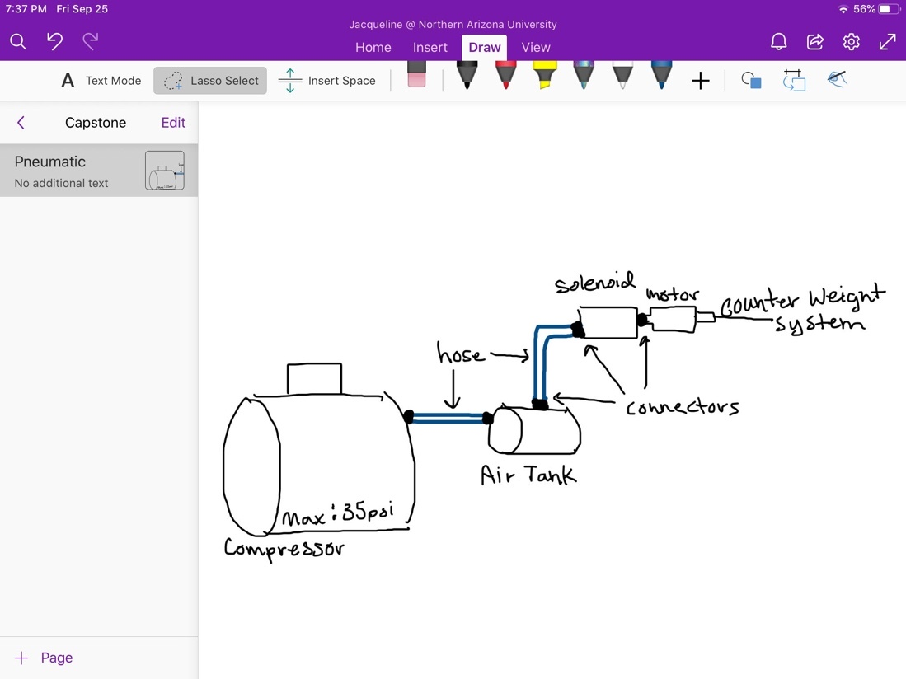

Figure 1: Pneumatic System Assembly Sketch

The first iteration of the design of this subsystem was to have almost every part internalized within the fixture. This meaning that the compressed air tank, would be internal, and it would be hooked up to the solenoids and then those would be attached to each motor. However, with the tank being inside of the fixture would make the size of the entire design be larger, and the tank would have to be minimized. The team wanted the device to be able to run multiple times, and with the tank being small then this could not occur. Therefore, the team decided it would be best to leave the tank outside of the fixture and have it attached through a hose.

The second iteration, then had the tank separate attaching to a valve within the device, which would then connect to a solenoid that would separate the air to the six different motors. As the team was setting up the Bill of Materials and finding products that they could buy for the device, it found difficult to purchase one solenoid that would be able to split to six different air flows. Also, having the compressed air separated into six different air flows would minimize the pressure going into each Pneumatic Motor, making those motors less efficient. There would also be a complication in setting up six different hosing mechanisms inside of the system. Instead, the team has landed on to the current iteration.

The current design has six different ports for the air tank to be connected to. These six ports start with a separate solenoid, that will communicate with the Arduino to know how long it must stay open. Then the solenoid is directly connected to the Pneumatic Motor, which is connected to the counter-weight assembly. The hosing from the Air Tank must be connected to each of the solenoids individually in a specific order. The team is setting up the code to pause after each solenoid opening time, so that the user of the device is able to disconnect and re-connect the air tank to the next position. This iteration was agreed upon since it will be the most efficient. The location of the solenoids on the fixture can be seen below in Figure 2.

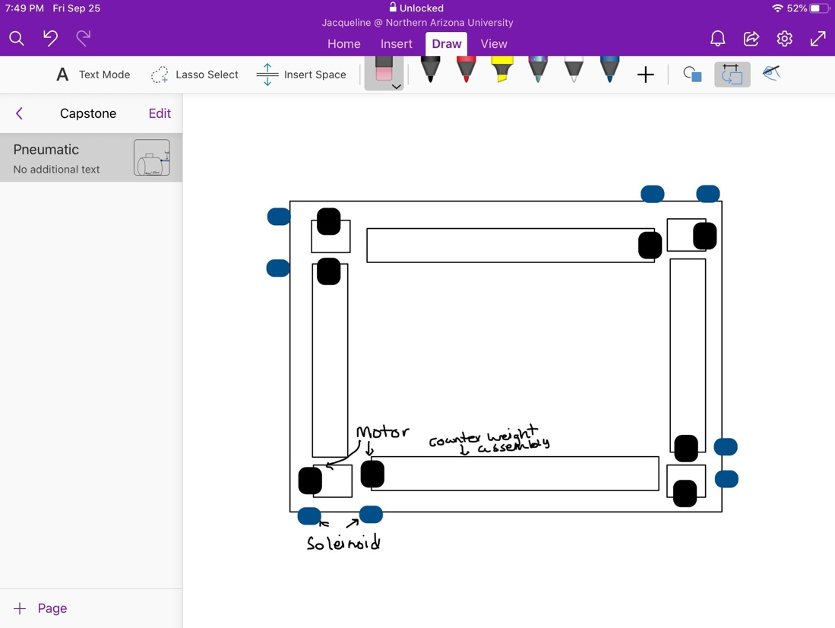

Figure 2: Motor/Solenoid Placement Sketch

The solenoids being on the outside of the device will allow for easy connections for the user to the air tank. This placement will also limit the amount of hosing used within the entire device, therefore limiting the amount of head loss within the air flow. Each of the solenoids will be connected to the Arduino that is going to be located in the center of the fixture.

For this current iteration, the team has purchased all of the associated parts to build it and are waiting for them to be shipped. A small pneumatic assembly was created to test the motors worked, and from there the actual assembly attached to the fixture, will be made.

## 3.2 Design Iteration 1: Change in Electrical Subsystem discussion

In the initial design, the electrical system consisted of the force sensors sending readings to the Arduino board, which in turn sends tells the solenoids to send air through the pneumatic motors for a certain amount of time, which is dependent on how far the counterweight needs to travel along the leadscrew. (Figure 3)

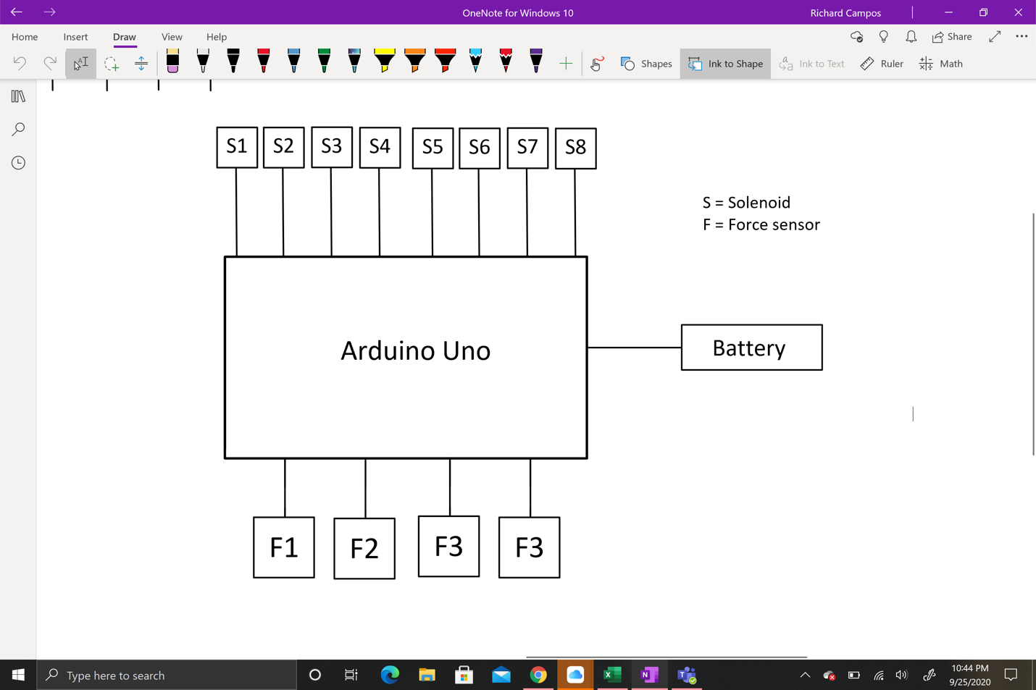

Figure 3: Original Electrical Subsystem

Since the team acquired some components for the prototype, some additions were suggested by team members. It was suggested that the team utilize a smaller battery for the device, because the one that the team has on hand is too large to fit inside the spherical cavity underneath the fixture. Another change that was made was the Arduino board that is being used for the fixture. The team also decided to incorporate accelerometers into the design for two reasons: to better detect if the device is at an upright angle, and to verify if the CG calculations are correct. It was decided that and Arduino Mega would better suit our needs over the Arduino Uno because there are more input and output ports that accommodate all of the onboard sensors. Additionally, as stated before, the team downsized the number of pneumatic motors being used in the system from eight to six, which led to the team changing the number of solenoids accordingly.

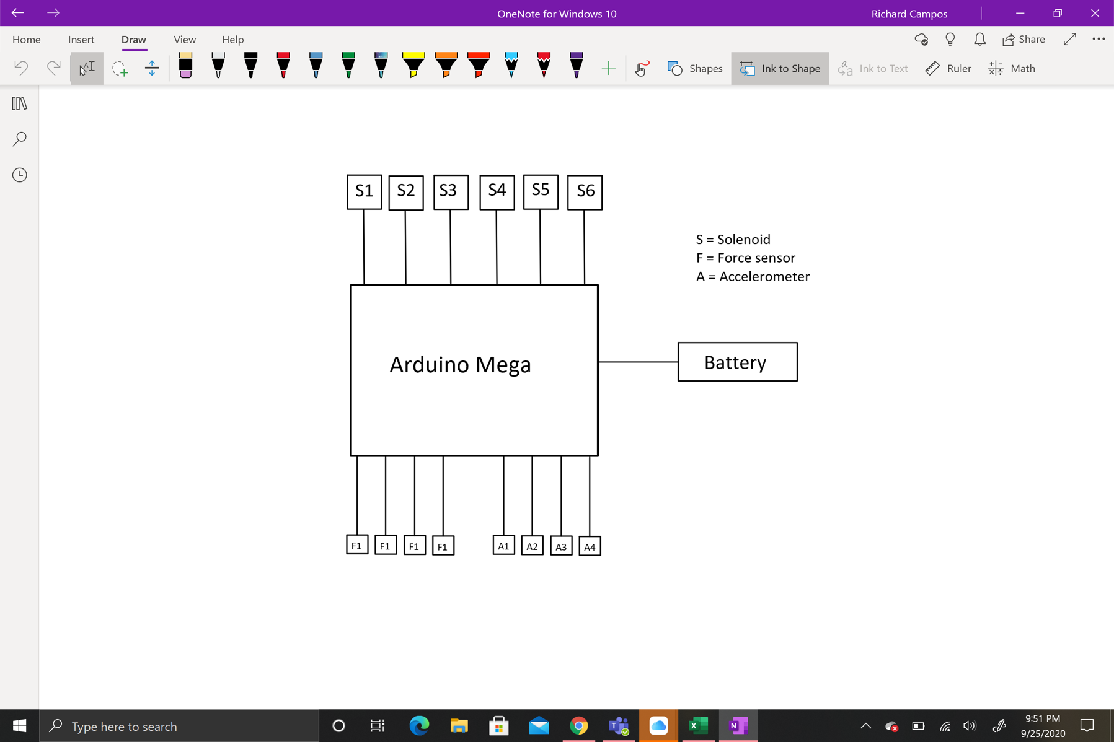

Figure 4: Current electrical subsystem

## 3.3 Design Iteration 1: Change in Counter-Weight Subsystem discussion

The original design for the mounting fixture includes 8 screw-weight (rail) assembly. There were four rail assemblies that adjust the CG in the x- and y- planes, that is moving the CG about the plane of the platform. The adjustment of the CG z-component used four additional rails assemblies oriented in the z-direction. Displacing the counterweight displaces the CG normal to the platform. The number of rails and their geometries were decided so that our device could be symmetrical about all three-coordinate axis. We anticipated the CG for the platform alone to be at the geometric center with absolute symmetry.

As the project advances, the team is addressing more details of the design as we are obtaining/requesting more documents from the customer. We initially designed our rail assemblies to adjust the CG for objects with awkward center of gravities, designing for the worst case. Our analysis for the counterweight system resulted in power screw lengths equal to length of the CubeSat edge, and 45 lbs counterweights. This design failed to stay below our ER for total weight. To address this concern, we obtained sample payload specs for GA’s 12U CubeSat. This information was not requested earlier as our device was supposed to accept other payloads and projectiles beyond just a CubeSat. Now our design is focused on testing only CubeSats, assuming the 12U is the largest. The team used the specs to adjust assumptions in the counterweight analysis. As a result, we only require 5 lbs for each counterweight, each power screw is 10 inches long, and we were able to remove two vertical rail assemblies from the design. Our CubeSat design now has 6 rails assemblies in total.

## 3.4 Design Iteration 1: Change in Clamping Subsystem discussion

Originally, the team was planning to use the clamping system given to us by General Atomics in the CSD document specifications. We created a CAD assembly for that system at the end of last semester to show it in our final CAD deliverable. After discussing machining costs and other variables associated with this clamping system, we decided to make a design change.

The design change will incorporate a rail system to hold the CubeSat in place without adding more force to throw off the center of gravity. Since aligning the center of gravity of the CubeSat with the center of gravity of our fixture is the team’s most significant design requirement, we don’t want to add excess force to throw off the calculations. The team is planning on using an aluminum L shaped bracket to secure the CubeSat and is shown in Figure 5 below. The L shaped brackets will allow the CubeSat to slide into the fixture and be secured in the x, y and z directions. After the CubeSat is slid into the rail system, the team plans to secure the open side by using a secure bracket. As of now, the team is planning on using a piece of material on a screw in order to fasten it securely to the fixture.

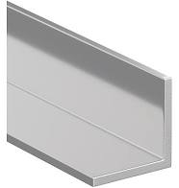

Figure 5. Aluminum L Bracket

The team is currently working on incorporating this design change into the CAD assembly but a sketch of this system is shown in Figure 6. This sketch shows where the L shaped brackets will be as well as how the fourth edge will be secured to the fixture. The brackets will be on three sides of the CubeSat in order to secure it in the y and z directions while the sliding piece will be implemented to secure the x axis. The team is planning on using this design iteration because the CubeSat can be slid into the clamping system and then secured by the fourth edge piece. This will ease the process of securing the CubeSat.

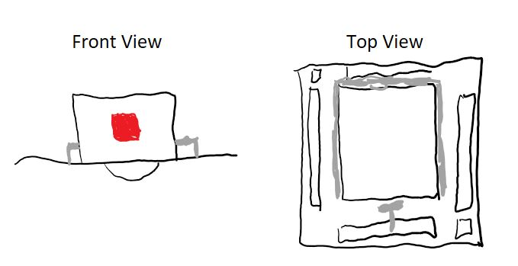

Figure 6. Clamping System

From the figure, it doesn’t show why we are using the L shaped brackets directly. Figure 7 below shows how the CubeSat will attach to the fixture along with the clamps General Atomics uses to secure it. The team is using L shaped brackets to make sure no weight or force changes occur during the clamping process to make sure determining the center of gravity is accurate.

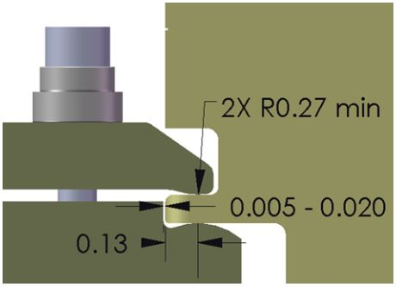

Figure 7. GA Clamping System

# 4.0 Future Work

The team has ordered most of the remaining parts required to build a working prototype. The team needs to order the rail system to secure the CubeSat to the fixture then we will be ready to assemble the prototype. The plan for the rest of the semester is to build each sub-assembly and then come together to put together a final prototype assembly. An updated report of what we have left to accomplish is shown in section 4.1. The team has updated the Gantt Chart to reflect the progress thus far in the project and the goal completion dates moving forward. This is highlighted in section 4.2.

## 4.1 Further Design

The team has started the prototyping process and will continue to work on this until the end of the semester. As of right now, the team has nearly completed the coding needed for the hardware. The team will need to finalize and combine these codes to ensure the fixture can run on one code. We plan on utilizing MATLAB as well as Arduino to complete this process. After the prototype is complete, the team must also test the code to ensure it works properly. From here on out, the team plans to build each sub-assembly and then ultimately combine these into a working prototype.

The first step for the team is to incorporate our design changes into the CAD model. Thereafter, we can begin to assemble the sub-assemblies. The team’s main goal at the beginning of the semester was to create the codes and making sure the center of gravity calculations were correct. During that process, the team also focused on purchasing orders to ensure parts would arrive in time to build a prototype. As of right now, the team just put together the last purchasing order and it is in the process of being approved. While we are waiting for that to arrive, we are making sure the codes work and starting the process of building sub-assemblies for what we have. The team is preparing a midpoint presentation for the next deliverable and focusing on having significant progress before the next hardware review.

We are working to build the sub-assemblies first and foremost and will then combine these into the final prototype. The sub-assemblies include: clamping, counter-weight system, electrical system and the pneumatic system. The team’s goals for the deliverables in the course and for our clients are highlighted in the Gantt chart. To ensure the team meets requirements of the course and the needs of the client, we are updating the Bill of Materials throughout each design change and addition. The team’s final deliverable to General Atomics is a working prototype and the team is in a good position to make this happen.

## 4.2 Schedule Breakdown

The team had initially planned to order the prototyping components during the first week of the semester, but unfortunately there was difficulty in getting a purchase order for the alpha prototype to the Engineering front desk, the team could not build the physical subsystems immediately when the semester began. Due to this, the semester schedule had to be adjusted in order to accommodate this setback. In the meantime, while the team waited for the parts to be delivered, different team members worked on separate parts of the fixture software. This was done so that when the different subsystems could be assembled, the team could immediately utilize the software. Additionally, the team's clients wanted an occasional weekly meeting with them so that they could better monitor the teams progress. GA also did not want to overload the team and themselves with unnecessary meetings, so it was decided that they would only occur when the team has progress of significant substance to relay.

Even though the team is experiencing time delays in our schedule, we still anticipate the final prototype to be finished and presentable by the time that the semester ends. To see the changes that have been made to the semester schedule, both Gantt charts can be found in the Appendix.

**Appendix**

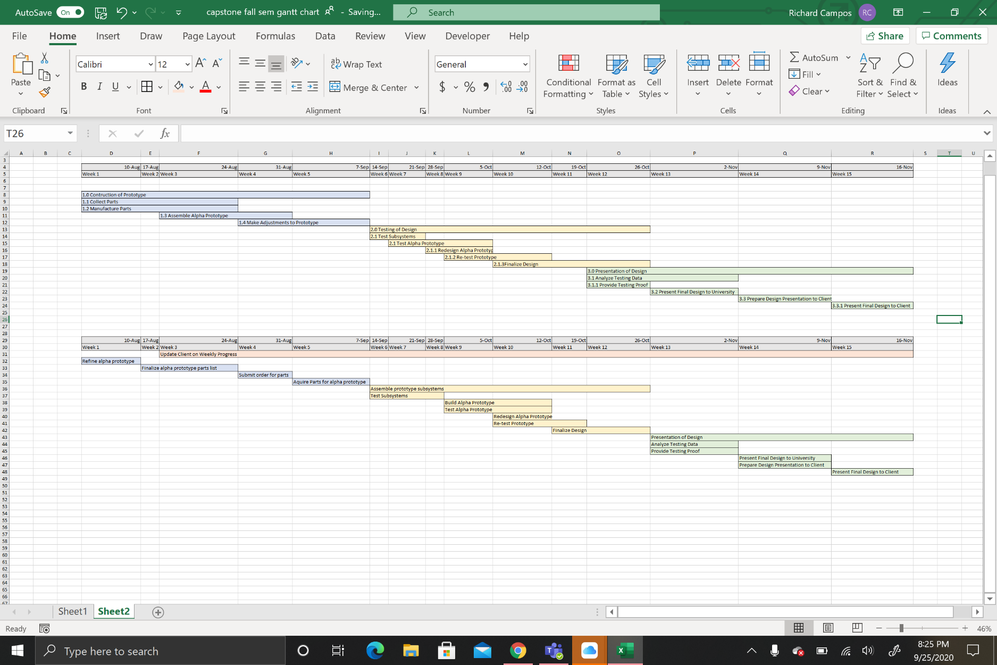

Figure 8: Original Gantt Chart (left) and Adjusted Gantt Chart (right)